**INSTALL SSM AGENT ON LINUX**

STEP 1- Create an ec2 instance and install ssm agent on it by commands given below-

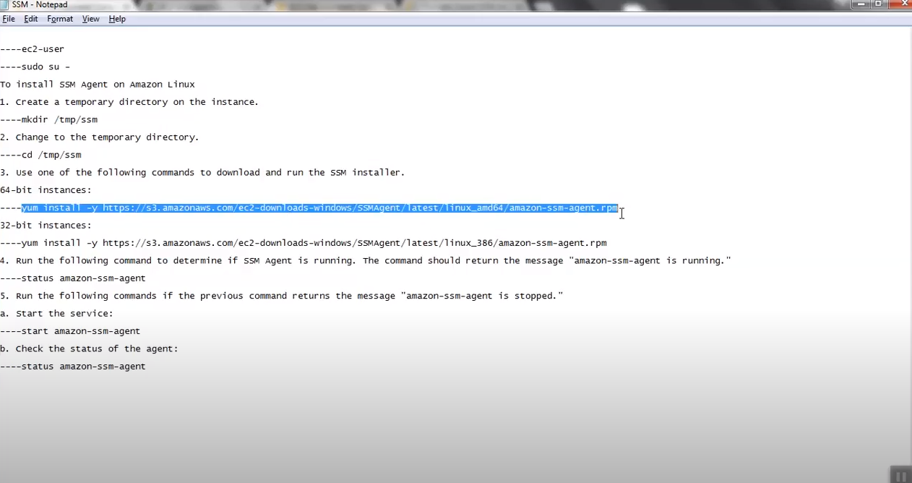

Step-2

Create a role (ssm role) for EC2 **(role for simple system manager)** and attach it with instance

Step-3

Now go to system manager in console and run a command (AWS-RunShellScript) and attach instance with it

